Program No. 01. >> Installation and Setup of R/RStudio
Objective: To install R and RStudio and understand the basic working environment of R programming.
Tasks:
- Install R and RStudio on the system
- Explore RStudio interface (Console, Script, Environment, Plots)
- Run basic R commands
- Display “Welcome to R Programming”
Outcome: Students will be able to install R/RStudio and execute basic R programs successfully.
Tools Used: R, RStudio

Script/Code:
Step 1: Install R
- Open a web browser.
- Go to CRAN R official website. : https://cran.r-project.org/

- Download the latest version of R according to your operating system (Windows / macOS / Linux).
- Run the installer and complete the installation using default settings.

Step 2: Install RStudio
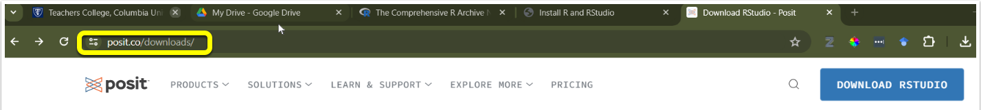
- Visit the RStudio official website. : https://posit.co/downloads/

- Download RStudio Desktop (Free version).
- Install RStudio after R installation is completed.

Step 3: Open RStudio
- Launch RStudio.
- Observe the main components:
  - Console – Executes R commands
  - Source – Write R scripts
  - Environment – Shows variables and objects
  - Plots / Files / Help – Displays outputs and help

Program Execution:
Step 5: Write and Execute the Program
- Click File → New File → R Script
- Type the following program.
# Program to display Welcome message
print("Welcome to R Programming")
- Save the file. → ‘firstProgam.R’
- Click Run or press Ctrl + Enter.
Output:
[1] "Welcome to R Programming"
Installation Screens:
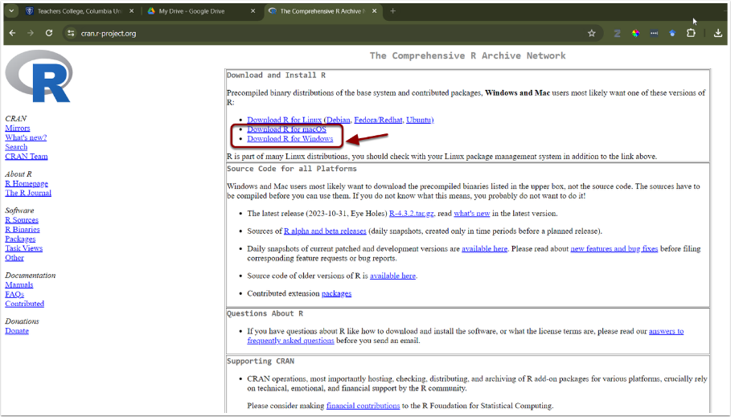
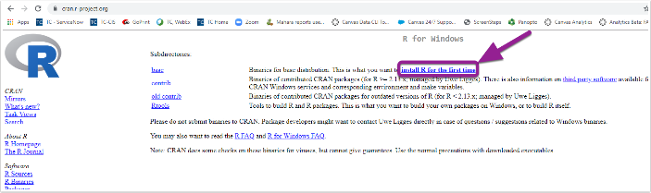
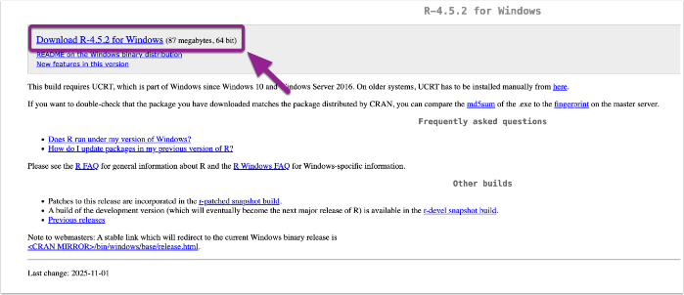
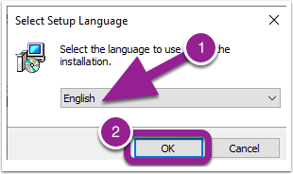
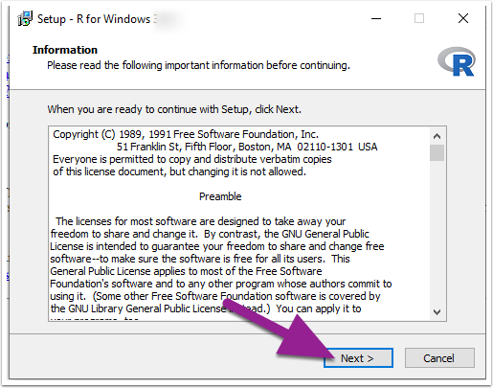
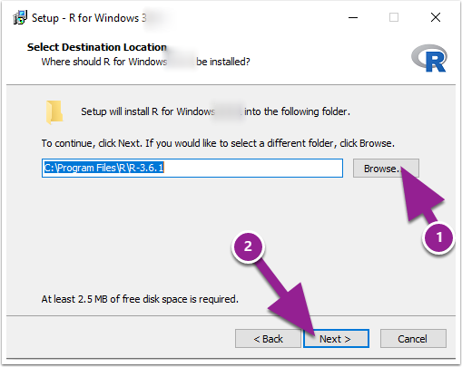
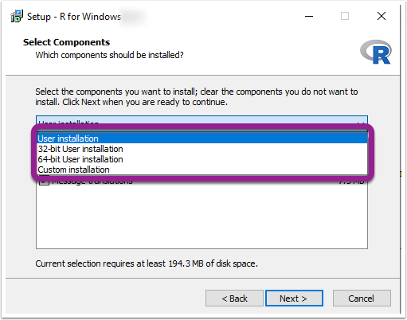
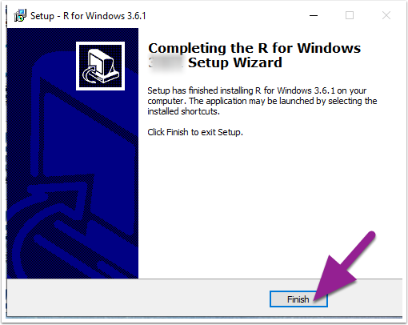
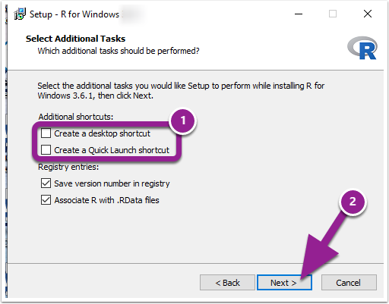
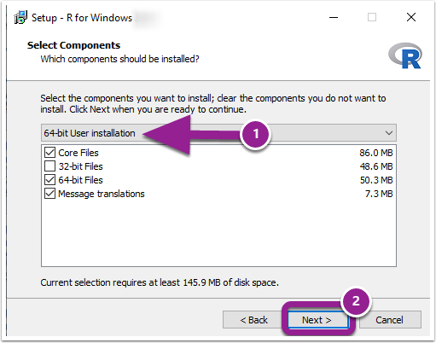
R Installation - https://cran.r-project.org/

Installation Screens:
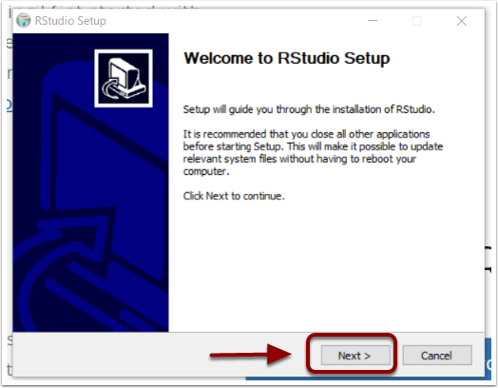
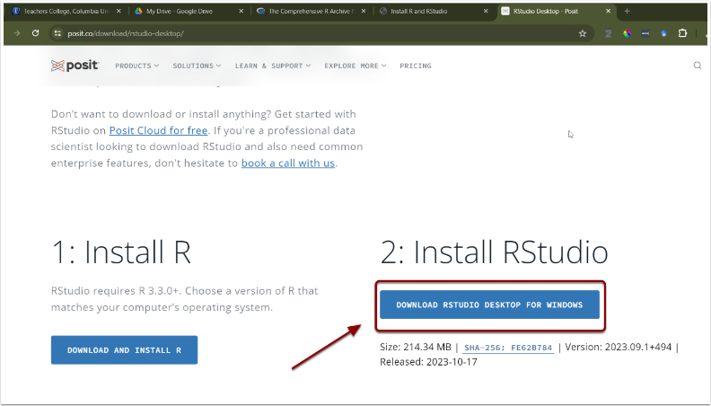
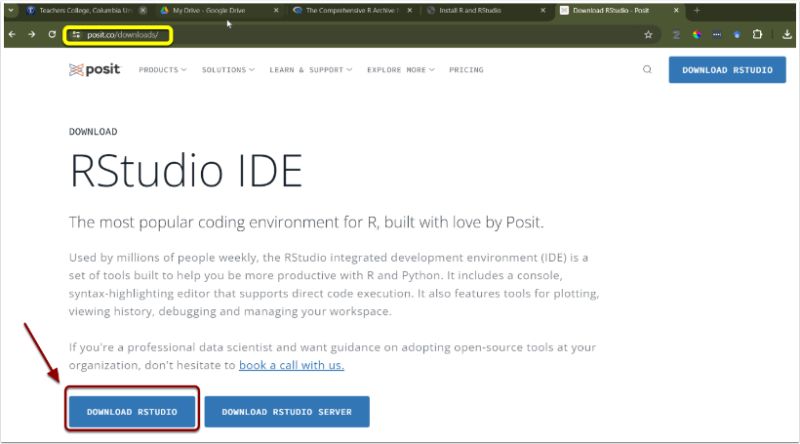
RStudio Installation: https://posit.co/downloads/

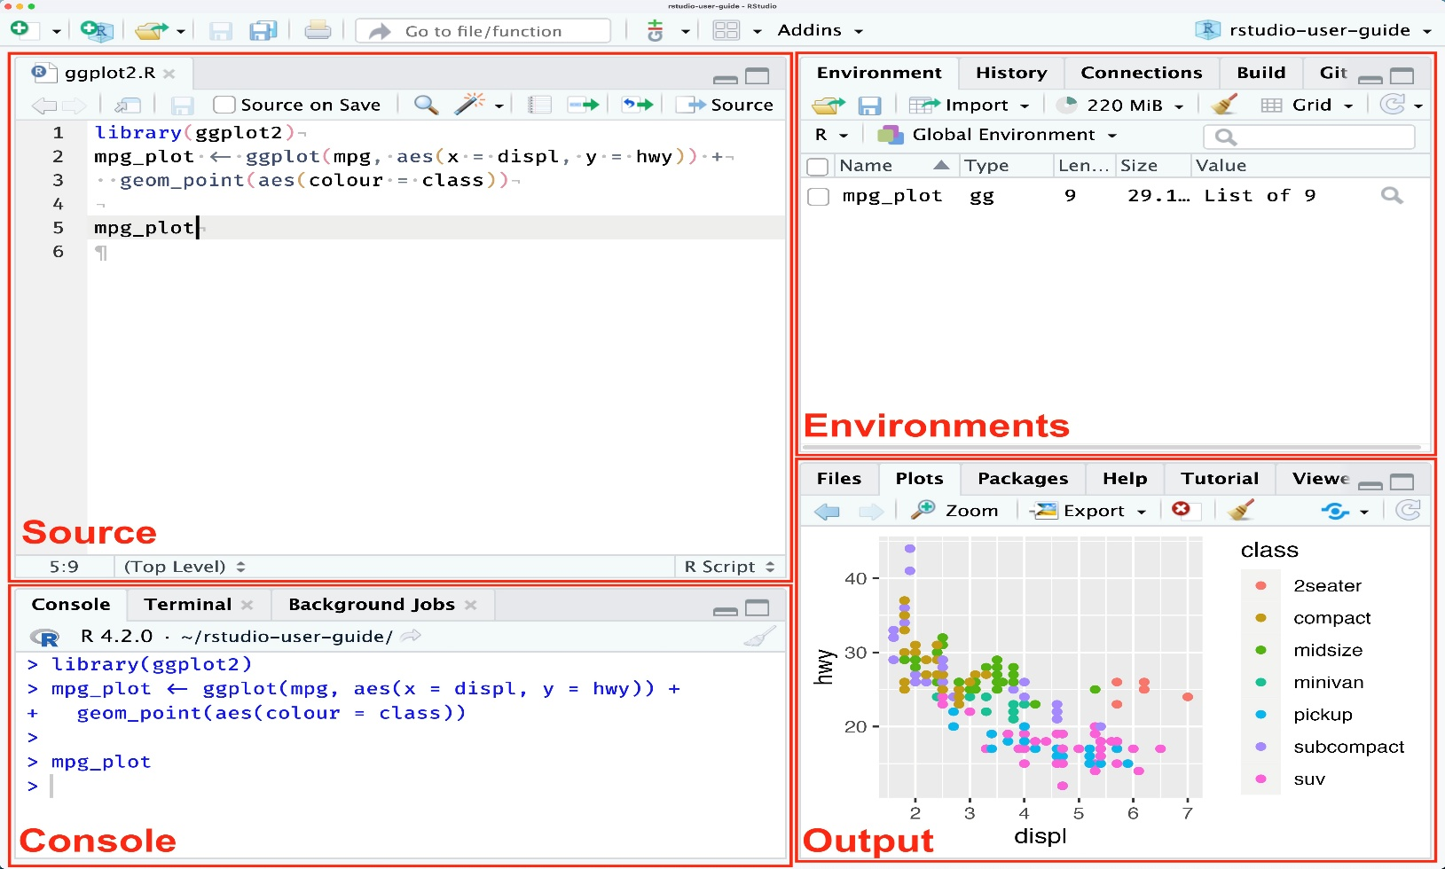
RStudio IDE Interface:
Thank You!!

Program No. 02. >> Arithmetic Operations on Two Numbers
Objective: To perform basic arithmetic operations using R programming.
Tasks:
- Take two numeric values
- Calculate sum, difference, product, and division
- Display the results
Outcome: Students will understand basic arithmetic operations in R..
Tools Used: R, RStudio

Script:
# Program to perform arithmetic operations on two numbers

# Assign values to variables
a <- 10
b <- 5

# Arithmetic operations
sum <- a + b
difference <- a - b
product <- a * b
division <- a / b

# Display results
cat("Sum =", sum, "\n")
cat("Difference =", difference, "\n")
cat("Product =", product, "\n")
cat("Division =", division, "\n")

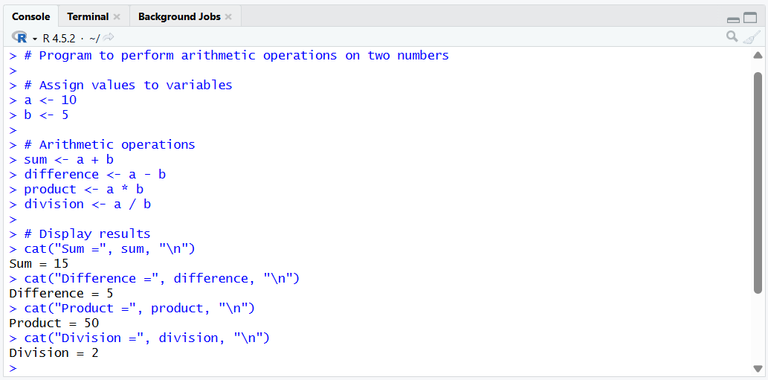
Output:

Program No. 03. >> Variables and Operators in R
Objective: To understand variables, data types, and operators in R.
Tasks:
- Create variables of different data types
- Perform arithmetic, relational, and logical operations
- Display data types using appropriate functions
Outcome: Students will be able to use variables and operators effectively in R.
Tools Used: R, RStudio

Script:
# Creating variables of different data types
integer_var <- 42L # Integer
numeric_var <- 3.14 # Numeric (double)
character_var <- "Hello, World!" # Character
logical_var <- TRUE # Logical
complex_var <- 2 + 3i # Complex
# Creating a factor variable
factor_var <- factor(c("red", "green", "blue"))

# Displaying variable types
cat("Type of integer_var:", class(integer_var), "\n")
cat("Type of numeric_var:", class(numeric_var), "\n")
cat("Type of character_var:", class(character_var), "\n")
cat("Type of logical_var:", class(logical_var), "\n")
cat("Type of complex_var:", class(complex_var), "\n")
cat("Type of factor_var:", class(factor_var), "\n")

# Displaying the structure of each variable
str(integer_var)
str(numeric_var)
str(character_var)
str(logical_var)
str(complex_var)
str(factor_var)

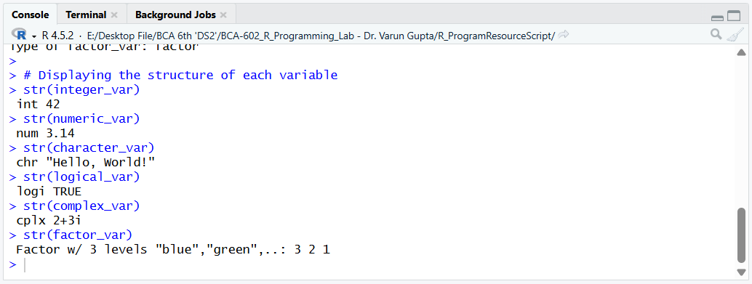
Output:
Program No. 04. >> Vectors and Vectorized Operations
Objective: To understand vector creation and vectorized operations in R.
Tasks:
- Create vectors
- Perform operations: min(), max(), mean(), sqrt(), length(), sum(), prod()
- Sort vectors in ascending and descending order
- Reverse vector elements
- Perform arithmetic operations on two vectors
- Create a list containing vector, matrix, and list
- Update list elements
- Merge two lists
- Count number of objects in a list
Outcome: Students will gain knowledge of vector and list operations in R.
Tools Used: R, RStudio

Script:
# Create two vectors
vector1 <- c(1, 2, 3, 4, 5)
vector2 <- c(6, 7, 8, 9, 10)

# Perform vectorized arithmetic operations
sum_vector <- vector1 + vector2
difference_vector <- vector1 - vector2
product_vector <- vector1 * vector2
division_vector <- vector1 / vector2

# Display results
cat("Sum of vectors:", sum_vector, "\n")
cat("Difference of vectors:", difference_vector, "\n")
cat("Product of vectors:", product_vector, "\n")
cat("Division of vectors:", division_vector, "\n")
print("---------------------------------------------")

# Perform other vector operations
min_value <- min(vector1)
max_value <- max(vector1)
mean_value <- mean(vector1)
sqrt_values <- sqrt(vector1)
length_value <- length(vector1)
sum_value <- sum(vector1)
prod_value <- prod(vector1)
sorted_asc <- sort(vector1)
sorted_desc <- sort(vector1, decreasing = TRUE)
reversed_vector <- rev(vector1)

# Display other vector operation results
cat("Min value:", min_value, "\n")
cat("Max value:", max_value, "\n")
cat("Mean value:", mean_value, "\n")
cat("Square root of values:", sqrt_values, "\n")
cat("Length of vector:", length_value, "\n")
cat("Sum of values:", sum_value, "\n")
cat("Product of values:", prod_value, "\n")
cat("Sorted in ascending order:", sorted_asc, "\n")
cat("Sorted in descending order:", sorted_desc, "\n")
cat("Reversed vector:", reversed_vector, "\n")
cat("---------------------------------------------", "\n")

# Create a list containing a vector, matrix, and list
my_list <- list(
my_vector = c(1, 2, 3),
my_matrix = matrix(1:6, nrow = 2),
my_sublist = list(a = "Hello", b = "World")
)

# Update the elements in the list
my_list[[1]] <- c(4, 5, 6)
my_list[[2]] <- matrix(7:12, nrow = 2)
my_list[[3]]$a <- "Hi"
my_list[[3]]$b <- "There"

# Merge two lists into one list
list1 <- list(x = 1, y = 2)
list2 <- list(z = 3, w = 4)
merged_list <- c(list1, list2)

# Count number of objects in a given list
num_objects <- length(my_list)

# Display results using paste()
msg1 <- paste("Updated list:", my_list, "\n")
msg2 <- paste("Merged list:", merged_list, "\n")
msg3 <- paste("Number of objects in the list:", num_objects, "\n")
cat(msg1, msg2, msg3, "\n")

Output:
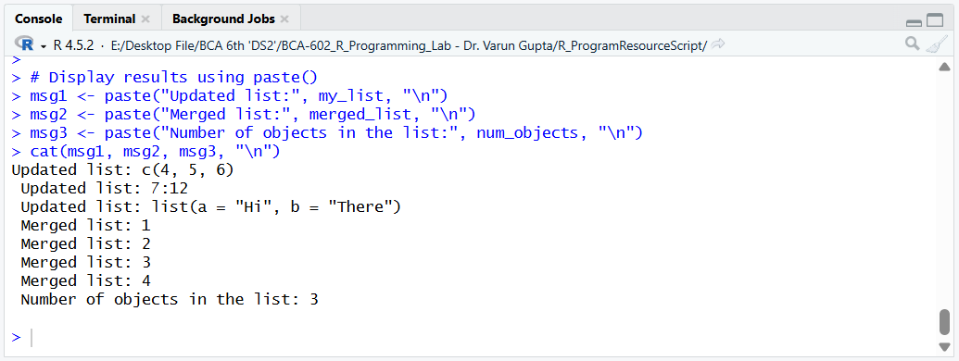
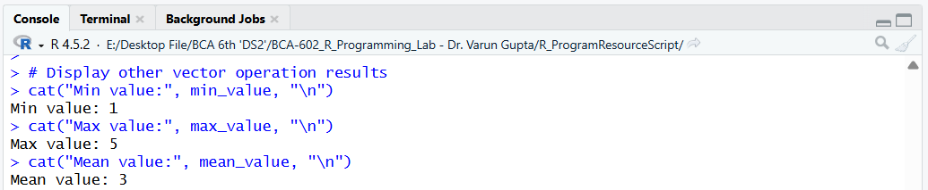
Program No. 05. >> Sub-setting Data in R
Objective: To understand sub-setting techniques in R.
Tasks:
- Create a vector of 10 elements
- Extract even-indexed elements using indexing
Outcome: Students will be able to subset data using indexing methods.
Tools Used: R, RStudio

Script:
# Create a vector of 10 elements
my_vector <- c(10, 20, 30, 40, 50, 60, 70, 80, 90, 100)

# Extract even-indexed elements
even_indexed_elements <- my_vector[seq(1, length(my_vector), 2)]

# Display the even-indexed elements
cat("Even-indexed elements:", even_indexed_elements, "\n")

# Extract elements using logical conditions (e.g., values greater than 50)
greater_than_50 <- my_vector[my_vector > 50]

# Display elements greater than 50
cat("Elements greater than 50:", greater_than_50, "\n")

# Name the elements of the vector
names(my_vector) <- c("a", "b", "c", "d", "e", "f", "g", "h", "i", "j")

# Extract elements using names
named_elements <- my_vector[c("a", "c", "e")]

# Display the named elements
cat("Named elements:", named_elements, "\n")

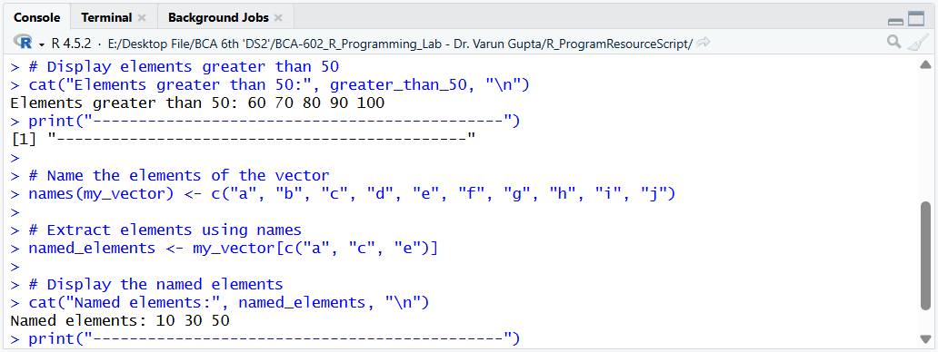
Output:

Program No. 06. >> Handling NA and NULL Values
Objective: To handle missing values in R.
Tasks:
- Create a vector with NA values
- Detect and remove NA values
- Apply proper coding standards
Outcome: Students will be able to manage missing data effectively.
Tools Used: R, RStudio

Script:
# Create a vector with NA values
my_vector <- c(1, 2, NA, 4, NA, 6)

# Detect NA values
na_values <- is.na(my_vector)

# Remove NA values
my_vector <- my_vector[!na_values]

# Display the vector after removing NA values
cat("Vector after removing NA values:", my_vector, "\n")
print("---------------------------------------------")

# Replace NA values with a specific value (e.g., 0)
my_vector_with_na <- c(1, 2, NA, 4, NA, 6)
my_vector_with_na[is.na(my_vector_with_na)] <- 0

# Display the vector with replaced NA values
cat("Vector with replaced NA values:", my_vector_with_na, "\n")
print("---------------------------------------------")

# Create a vector with NULL values
my_vector_with_null <- c(1, 2, NULL, 4, NULL, 6)

# Detect NULL values
null_values <- is.null(my_vector_with_null)

# Remove NULL values
my_vector_with_null <- my_vector_with_null[!null_values]

# Display the vector after removing NULL values
cat("Vector after removing NULL values:", my_vector_with_null, "\n")
print("---------------------------------------------")

# Replace NULL values with a specific value (e.g., 0)
my_vector_with_null[is.null(my_vector_with_null)] <- 0

# Display the vector with replaced NULL values
cat("Vector with replaced NULL values:", my_vector_with_null, "\n")
print("---------------------------------------------")

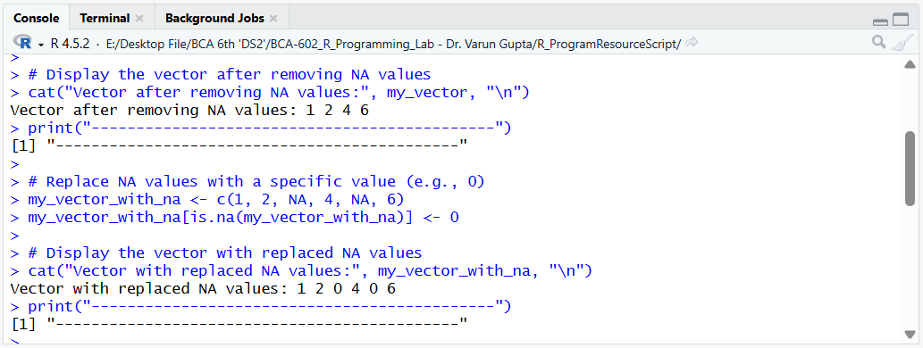
Output:

Program No. 07. >> Conditional Statements in R
Objective: To implement decision-making using conditional statements.
Tasks:
- Use if, if-else, and nested if-else statements
- Write a program to check whether a year is a leap year
Outcome: Students will understand conditional logic in R.
Tools Used: R, RStudio

Script:
# Check if a year is a leap year
year <- 2024
if ((year %% 4 == 0 && year %% 100 != 0) || (year %% 400 == 0)) {
cat(year, "is a leap year.\n")
} else {
cat(year, "is not a leap year.\n")
}
print("---------------------------------------------")

# Check if a number is positive, negative, or zero
number <- -5
if (number > 0) {
cat(number, "is positive.\n")
} else if (number < 0) {
cat(number, "is negative.\n")
} else {
cat(number, "is zero.\n")
}
print("---------------------------------------------")

# Check if a number is even or odd
number <- 7
if (number %% 2 == 0) {
cat(number, "is even.\n")
} else {
cat(number, "is odd.\n")
}
print("---------------------------------------------")

# Nested if-else to determine grade based on score
score <- 85
if (score >= 90) {
cat("Grade: A\n")
} else if (score >= 80) {
cat("Grade: B\n")
} else if (score >= 70) {
cat("Grade: C\n")
} else if (score >= 60) {
cat("Grade: D\n")
} else {
cat("Grade: F\n")
}
print("---------------------------------------------")

# Take user input for age and determine if they are a child, teenager, adult, or senior
age <- as.integer(readline(prompt = "Enter your age: "))
if (age < 13) {
cat("You are a child.\n")
} else if (age < 20) {
cat("You are a teenager.\n")
} else if (age < 65) {
cat("You are an adult.\n")
} else {
cat("You are a senior.\n")
}
print("---------------------------------------------")

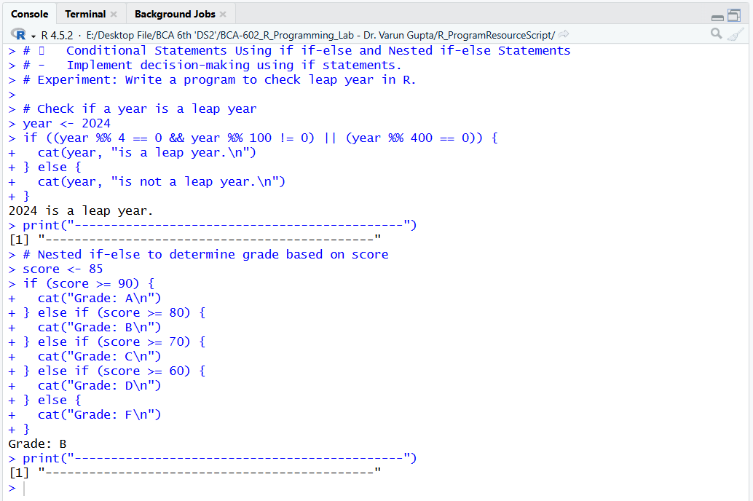
Output:

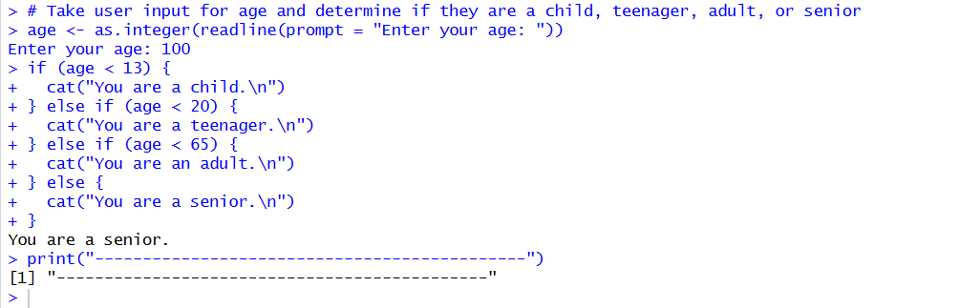
# Input Taken : Output
Program No. 08. >> Loop Implementation in R
Objective: To understand looping structures in R.
Tasks:
- Generate Fibonacci series using while loop
- Generate multiplication table using for loop
- Create a simple calculator using loops and conditions
Outcome: Students will be able to use loops for repetitive tasks.
Tools Used: R, RStudio

Script:
# 1. Fibonacci series using while loop
fibonacci <- function(n) {
a <- 0
b <- 1
count <- 0

if (n <= 0) {
return("Please enter a positive integer.")
} else if (n == 1) {
return(a)
} else {
fib_series <- c(a, b)
while (count < n - 2) {
next_fib <- a + b
fib_series <- c(fib_series, next_fib)
a <- b
b <- next_fib
count <- count + 1
}
return(fib_series)
}
}

# Example usage:
n <- 10
result <- fibonacci(n)
print(result)

# 2. Multiplication table of a number using for loop
number <- 5
# number <- as.numeric(readline(“Enter the number:”))
cat("Multiplication Table of", number, ":\n")
for (i in 1:10) {
result <- number * i
cat(number, "x", i, "=", result, "\n")
}

# 3. Simple calculator program
calculator <- function() {
cat("Simple Calculator\n")
cat("Enter first number: ")
num1 <- as.numeric(readline())
cat("Enter second number: ")
num2 <- as.numeric(readline())
cat("Choose operation (+, -, *, /): ")
operation <- readline()

switch(operation,
"+": result <- num1 + num2,
"-": result <- num1 - num2,
"*": result <- num1 * num2,
"/": result <- num1 / num2,
stop("Invalid operation.")
)

cat("Result: ", result, "\n")
}

# Example usage:
calculator()

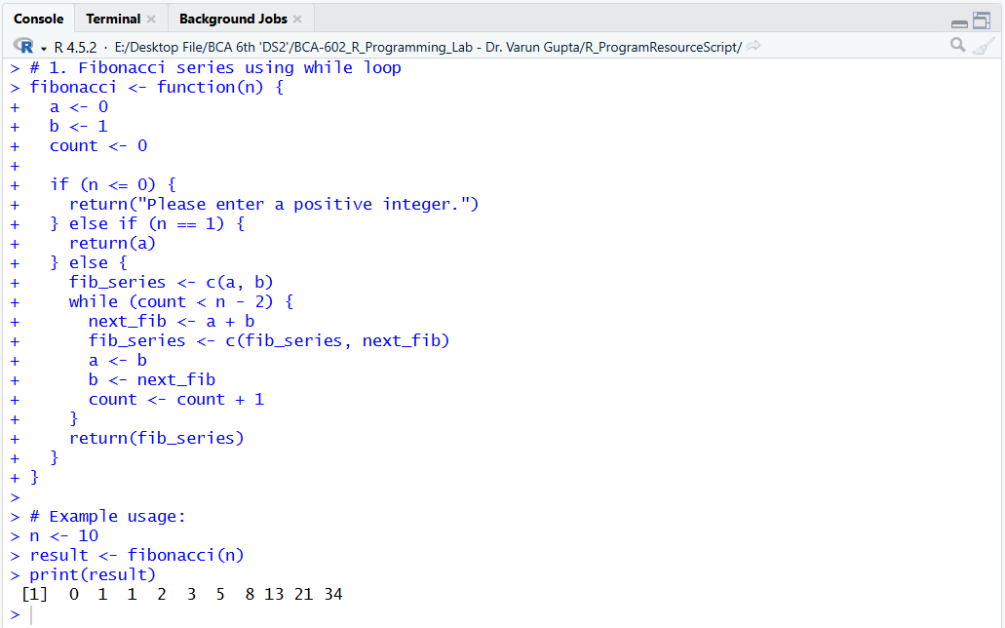
Output:

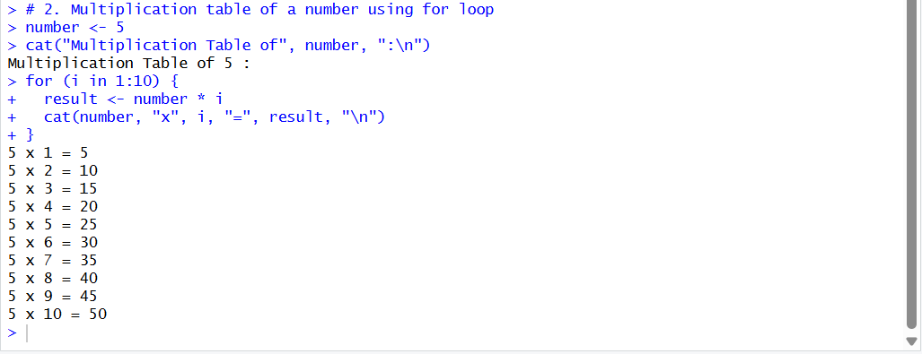
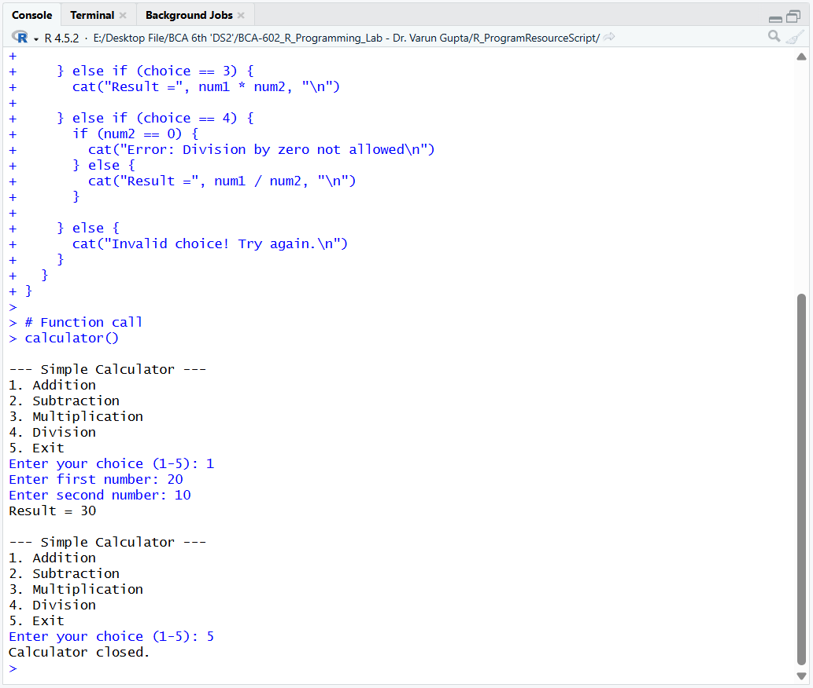
Calculator

Program No. 09. >> Scoping Rules in R
Objective: To understand local and global variable scope in R.
Tasks:
- Define a variable outside a function
- Modify it inside a function
- Display variable values before and after function execution
Outcome: Students will understand variable scope and function behavior.
Tools Used: R, RStudio

Script:
# Global Variable
global_var <- 10
cat("Value of global variable before function execution:", global_var, "\n")

# Function to modify the global variable
modify_global <- function() {
global_var <- 20
cat("Value of global variable inside function:", global_var, "\n")
}

# Function call
modify_global()

# Display the value of the global variable after function execution
cat("Value of global variable after function execution:", global_var, "\n")

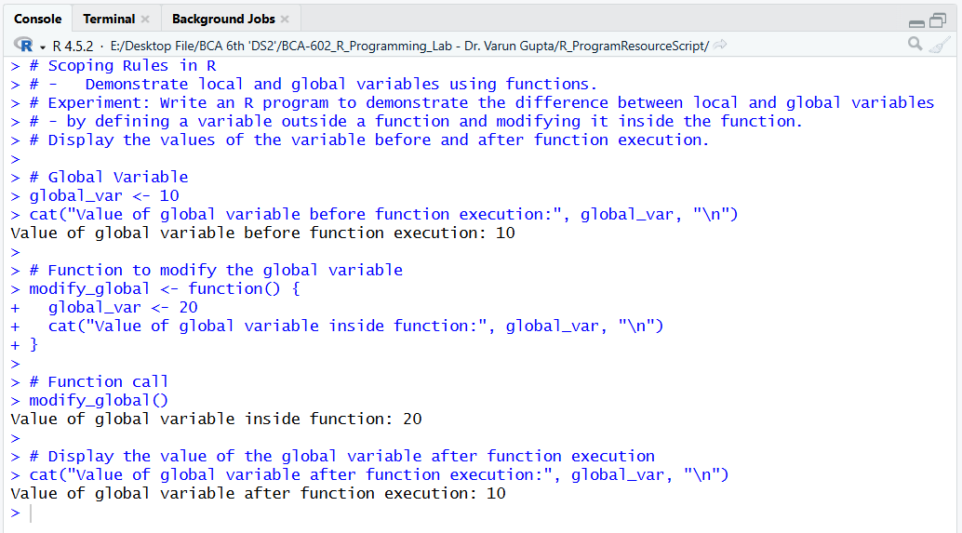
Output:

Program No. 10. >> Apply Family Functions
Objective: To use apply family functions in R.
Tasks:
- Apply apply(), lapply(), sapply(), and tapply() on a matrix
- Compare the outputs
Outcome: Students will be able to apply functional programming concepts in R.
Tools Used: R, RStudio

Script:
# Apply Family Functions
# - Use apply(), lapply(), sapply(), tapply() on matrices.
# Experiment: Use apply(), lapply(), sapply(), tapply() on matrix and compare the results.

# Create a matrix
my_matrix <- matrix(1:9, nrow = 3, ncol = 3)
print("Original Matrix:")
print(my_matrix)

# Apply function to each row
row_sums <- apply(my_matrix, 1, sum)
print("Row Sums:")
print(row_sums)

# Apply function to each column
col_products <- apply(my_matrix, 2, prod)
print("Column Products:")
print(col_products)

# Use lapply to calculate the mean of each column
col_means <- lapply(my_matrix, mean)
print("Column Means:")
print(col_means)

# Use sapply to calculate the standard deviation of each column
col_sd <- sapply(my_matrix, sd)
print("Column Standard Deviations:")
print(col_sd)

# Use tapply to calculate the sum of elements in each row
row_sums_taply <- tapply(my_matrix, 1, sum)
print("Row Sums (using tapply):")
print(row_sums_taply)

Output:

Function | Works On | Output Type | Best Use
apply() | Rows / Columns | Vector / Matrix | Matrix operations
lapply() | List / Columns | List | When list output is needed
sapply() | List / Columns | Vector / Matrix | Simplified output
tapply() | Groups | Vector / Array | Group-based calculation
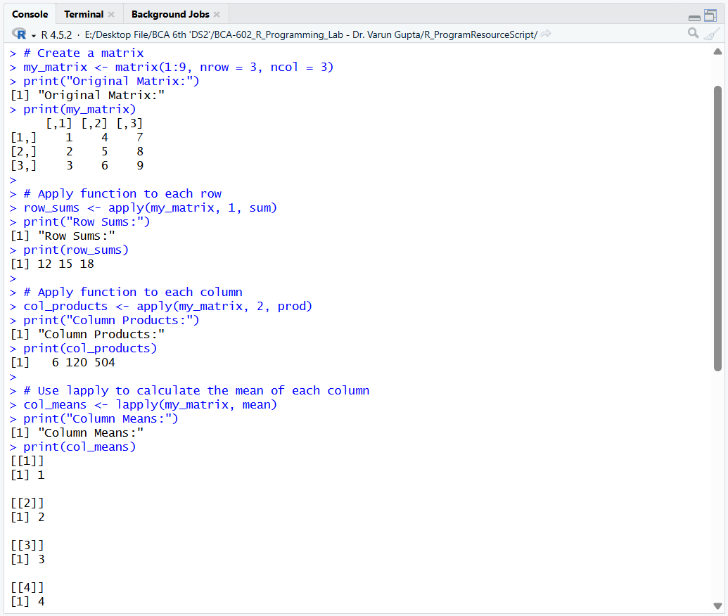

Program No. 11. >> Date, Time, and Sleep Functions
Objective: To work with system date, time, and delay functions.
Tasks:
- Display current system date and time
- Pause execution for 5 seconds using Sys.sleep()
Outcome: Students will understand date and time handling in R.
Tools Used: R, RStudio

Script:
# Display current system date
current_date <- Sys.Date()
cat("Current Date:", current_date, "\n")

# Display current system date and time
current_time <- Sys.time()
cat("Current Date & Time:", current_time, "\n")

# Pause execution for 5 seconds
cat("Program paused for 5 seconds...\n")
Sys.sleep(5)

cat("Program resumed after 5 seconds.\n")

Output:
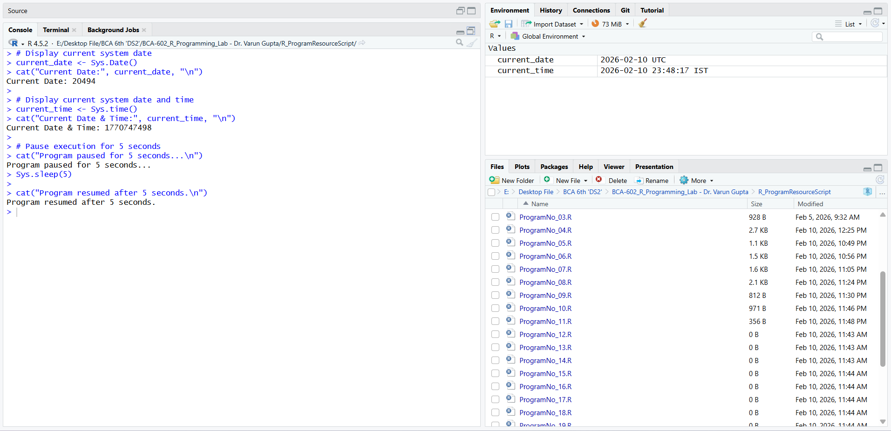
Program No. 12. >> Reading and Writing Data Files
Objective: To read and write external data files in R.
Tasks:
- Read a CSV file using read.csv()
- Display summary statistics
- Write data using write.csv()
Outcome: Students will be able to handle external data files in R.
Tools Used: R, RStudio

Script:
# Reading data from a CSV file
data <- read.csv("data.csv")

# Display first few rows
cat("First 6 rows of the data:\n")
head(data)

# Display summary statistics
cat("\nSummary Statistics:\n")
summary(data)

# Writing data to a new CSV file
write.csv(data, "output_data.csv", row.names = FALSE)

cat("\nData has been successfully written to output_data.csv\n")

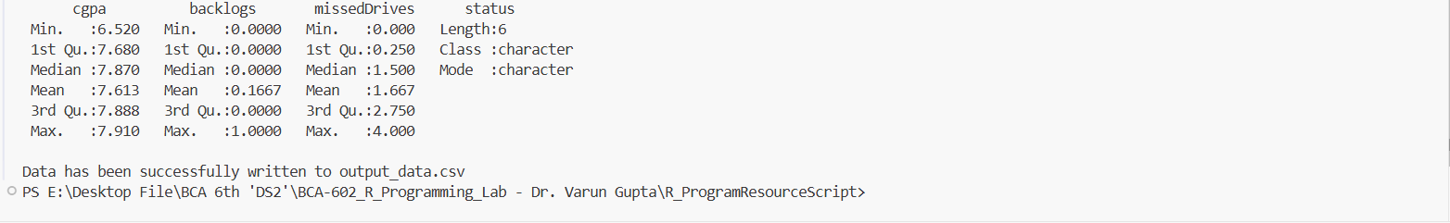
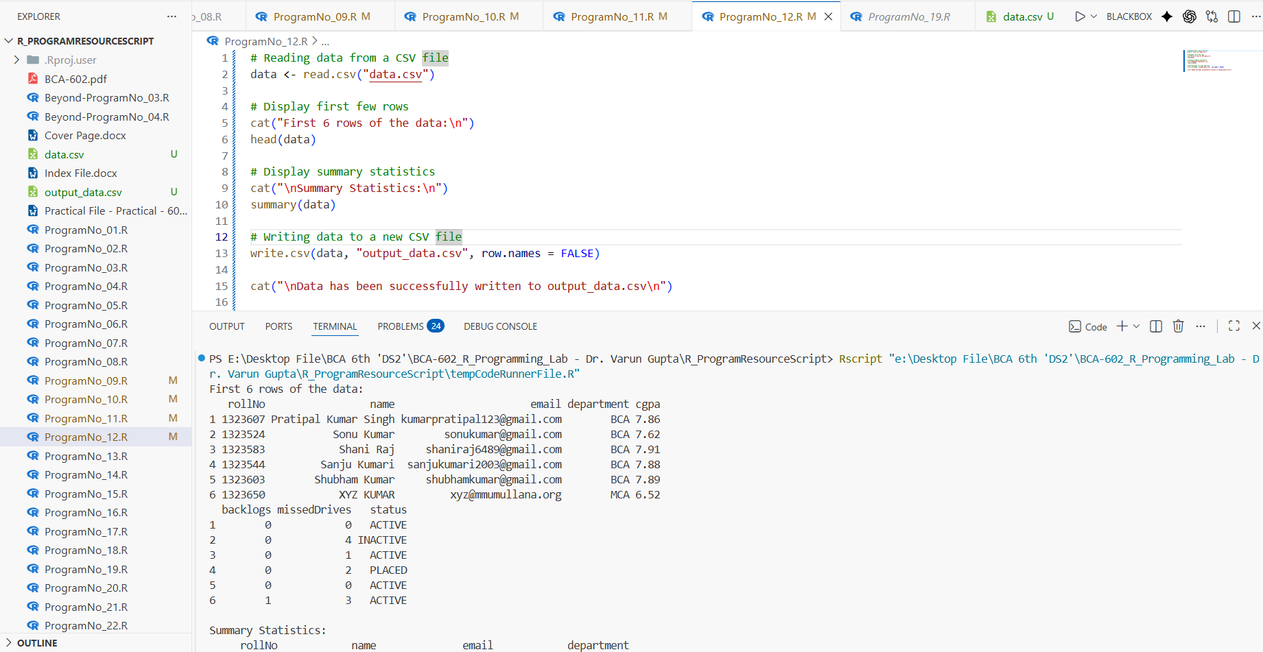
Output:
Practical 13: >> Saving and Loading R Objects
Objective: To save and load R data objects.
Tasks:
- Create an R object
- Save it using save()
- Reload it using load()
Outcome: Students will be able to store and reuse R objects.
Tools Used: R, RStudio

Script:

Output:

Program No. 14. >> Generating Data in R
Objective: To generate random data using built-in functions.
Tasks:
- Generate 100 random numbers between 1 and 50
- Store them in a vector
Outcome: Students will learn random data generation techniques.
Tools Used: R, RStudio

Script:

Output:

Program No. 15. >> Regular and Random Sequences
Objective: To generate sequences using R functions.
Tasks:
- Generate a sequence from 1 to 100 with step size 5
Outcome: Students will understand sequence generation in R.
Tools Used: R, RStudio

Script:

Output:

Program No. 16. >> Handling Missing Data
Objective: To handle missing values in datasets.
Tasks:
- Identify missing values
- Replace missing values with mean
Outcome: Students will be able to clean datasets effectively.
Tools Used: R, RStudio

Script:

Output:

Program No. 17. >> Creating and Manipulating Objects
Objective: To work with data frames in R.
Tasks:
- Create a data frame
- Display structure, summary, and nature of data
Outcome: Students will understand data frame manipulation.
Tools Used: R, RStudio

Script:

Output:

Program No. 18. >> Indexing and Accessing Values
Objective: To demonstrate indexing techniques in R.
Tasks:
- Create a matrix
- Extract sub-matrix based on condition
- Convert matrix into 1-D array
Outcome: Students will understand indexing in R objects.
Tools Used: R, RStudio

Script:

Output:

Program No. 19. >> Introduction to S3 and S4 Classes
Objective: To understand object-oriented programming concepts in R.
Tasks:
- Create simple S3 and S4 objects
- Demonstrate indexing on vectors, matrices, and data frames
Outcome: Students will gain knowledge of OOP concepts in R.
Tools Used: R, RStudio

Script:

Output:

Program No. 20. >> Reference Classes and User-Defined Functions
Objective: To implement reference classes in R.
Tasks:
- Create a reference class
- Perform basic arithmetic operations using it
Outcome: Students will understand advanced OOP features in R.
Tools Used: R, RStudio

Script:

Output:

Program No. 21. >> Creating Basic 2D and 3D Plots
Objective: To visualize data using plots in R.
Tasks:
- Create a scatter plot for two numeric variables
Outcome: Students will be able to visualize data graphically.
Tools Used: R, RStudio

Script:

Output:

Program No. 22. >> Customizing Graphs in R
Objective: To enhance graphical representation in R.
Tasks:
- Add title, axis labels, legend, and colors to a plot
Outcome: Students will be able to customize R graphs.
Tools Used: R, RStudio

Script:

Output:

Program No. 23. >> One-Way ANOVA Using R
Objective: To perform statistical analysis using ANOVA.
Tasks:
- Perform one-way ANOVA on a dataset
- Interpret the result
Outcome: Students will understand hypothesis testing using ANOVA.
Tools Used: R, RStudio

Script:

Output:

Program No. 24. >> Linear Regression Analysis
Objective: To implement linear regression in R.
Tasks:
- Design a tree map for department-wise student count
- Fit a linear regression model
• Plot regression line
• Interpret model output
Outcome: Students will be able to perform predictive analysis using R.
Tools Used: R, RStudio

Script:

Output:

